Ten Little Words
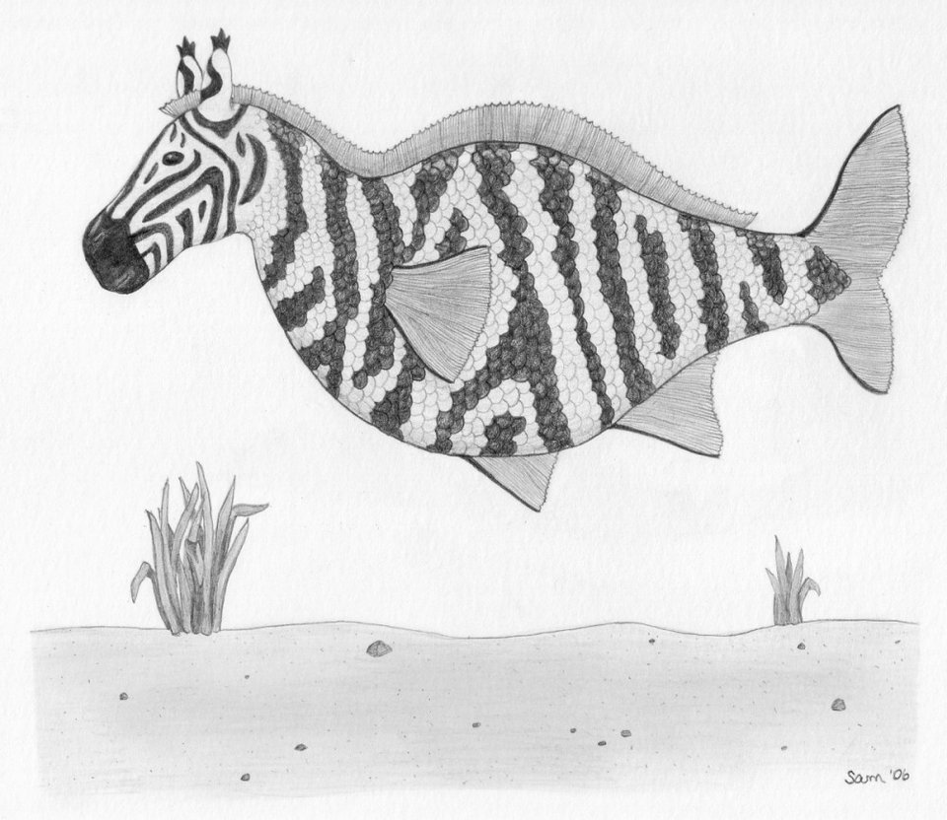Zebrafish

By Mitch Johnson

Clues

1. Complete set of eggs produced at one time (6)
Answer: ____________________
2. Mating strategy (12)
Answer: ____________________
3. An “all foods” consumer (8)
Answer: ____________________
4. Embryonic development outside the body of the mother (9)
Answer: ____________________
5. biological rhythm with 24-hour period (9)
Answer: ____________________
6. Male body shape (7)
Answer: ____________________
7. Genetically modified zebrafish with a bright body color (7)
Answer: ____________________
8. Stomachless & Toothless type of fish (8)
Answer: ____________________
9. Native subcontinent of zebrafish (5)
Answer: ____________________
10. Spindle-like body form (8)
Answer: ___________________
Letters
DO | NIV | FU | POL | OVI | TO
CAD | OFI | CL | GL | ITY | NID
SH | RPE | IAN | IN | CYP | UT
PAR | RI | ORM | YGY | ORE | DIA
CH | DRY | CIR | SIF | OM | NAN

Key
1. CLUTCH
2. POLYGYNANDRY
3. OMNIVORE
4. OVIPARITY
5. CIRCADIAN
6. TORPEDO
7. GLOFISH
8. CYPRINID
9. INDIA
10. FUSIFORM

Rubric

Criteria | High Proficiency | Total % | Rating | Comments
Construction/Organization | Layout of clues and answers are interesting and attractive | 30
Completeness | Each clue has corresponding answer | 10
Accuracy | Each answer is accurate | 10
Length | Number of clues and level of detail appropriate | 30
Audience Appropriate | Understood with general background in genetics/zebrafish | 20

